Volunteer Interest Form
Alta Loma Little League is a volunteer league. We need many volunteers to make a baseball season run smoothly. We know that everyone has many things to do each day. We appreciate any amount of time you can give.
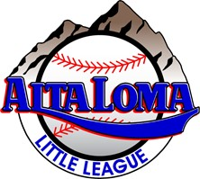
Please check all that may apply.
___ Field maintenance (mow fields, drag, after rain prep)
___ Snack bar manager (oversee the snack bar)
___ Opening Day Committee (help with the planning of Opening Day and make it a success)
___ Umpire (we can help and provide training)
___ Scorekeeper (we offer training and its fun!)
___ Manager (please sign up on our interest form and we provide training)
___ Coach (we can help and provide training)
___ Closing Day Activities (we never have enough help. More help more activities)

Name _______________________________________
Contact number _______________________________
Email ________________________________________

